**Government Arts College - Ooty**

**Department of Mathematics**

Mentor : Dr. N Anusheela

Team leader : Varshini S

Team member 1 : Vishnu T.S

Team member 2 : Sudharson J

Team member 3 : Velu G

# **Vehicle management Systemusing Salesforce**

**Introduction:**

Vehicle management is a crucial aspect of any transportation or logistics business, and it requires a robust system to handle the complex operations involved. Salesforce is a cloud-based customer relationship management (CRM) platform that offers a variety of tools and features for managing business operations. Using Salesforce for vehicle management can provide a powerful solution to streamline and optimize various aspects of vehicle management, including tracking, maintenance, and scheduling.

**Body**:

Salesforce provides a range of features that can be utilized for vehicle management. For example, the platform's database can be used to store information about vehicles, including their make, model, and year. This information can be easily accessed and updated by authorized personnel, such as fleet managers or maintenance technicians. Salesforce also offers tools for scheduling vehicle maintenance, such as oil changes or tire rotations, and tracking vehicle usage to ensure timely servicing.

One of the key benefits of using Salesforce for vehicle management is the ability to automate many tasks. For example, alerts can be set up to notify maintenance technicians when a vehicle is due for service, or when a part needs to be replaced. This helps to ensure that vehicles are always in good condition and reduces the risk of breakdowns or other issues that could impact business operations.

Salesforce also offers powerful reporting tools that can provide insights into various aspects of vehicle management. For example, reports can be generated to show fuel consumption across the fleet, or to identify vehicles that are not being utilized efficiently. This data can be used to make informed decisions about fleet management and to identify areas for improvement.

**Problem Definition & Design Thinking**:

**Empathy Map:**

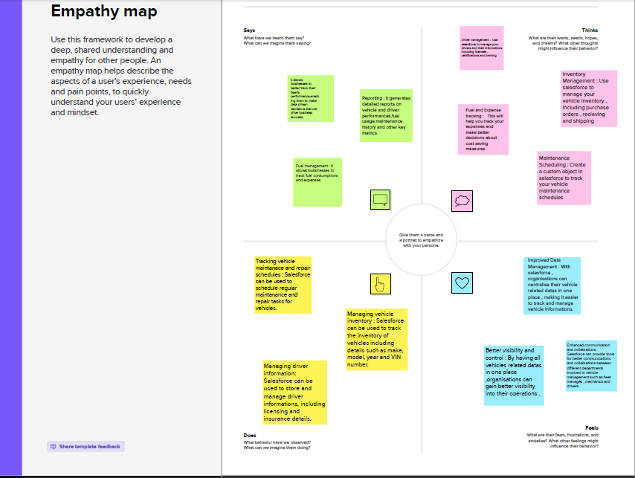

**Ideation & Brainstorming Map:**

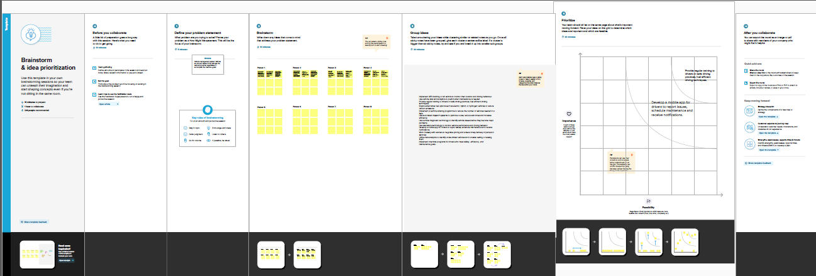

**Result:**

|  |  |
| --- | --- |
| Object Name | Fields in the Object |
| Vehicle | |  |  | | --- | --- | | Field Label | Data Type | | Customer Name | Text | | Customer Mobile No | Number | | Vehicle Type  i)2 wheeler  ii)4 wheeler | Picklist | | 2WHEELERS  i) HERO  ii)HONDA  iii)BAJAJ  iv)ROYAL ENFIELD  v)TVS  vi)KINETIC  vii)OLA  viii)JAWA  ix)SD  x)BATTERY | Picklist | | 4WHEELERS  i) RENAULT  ii)SKODA  iii) HONDA  iv)HYUNDAI  v)SUZUKI  vi)MAHINDRA  vii)VOLKSWAGEN  viii)BENZ  ix)AUDI  x)VOLVO | Picklist | | Vehicle Name | Text | | Vehicle No | Text | | Chassic No | Text | | Colour | Text | | Body Type | Text | | Vehicle Includes  i)Fire Extenuation  ii)First Aid Kit  iii)Multi Charger kit  iv)Stepney  v)Stereo  vi)Tool Kit  vii)Tracking Device  viii)Tyre Jack | Multipicklist | | Condition  i)Good  ii)Medium  iii)Least | Picklist | | Mileage | Text | | Seats | Number | | Start Date | Date/Time | | End Date | Date/Time | | Opportunity | Lookup (opportunities) | |  |  | |
| Driver | |  |  | | --- | --- | | Driver Name | Text | | Licence No. | Text | | Mobile No. | Number | | Fair Per Hour | Text | | Vehicle | Lookup(Vehicle) | |  |  | |

**Activity & Screenshot**:

**Object:**

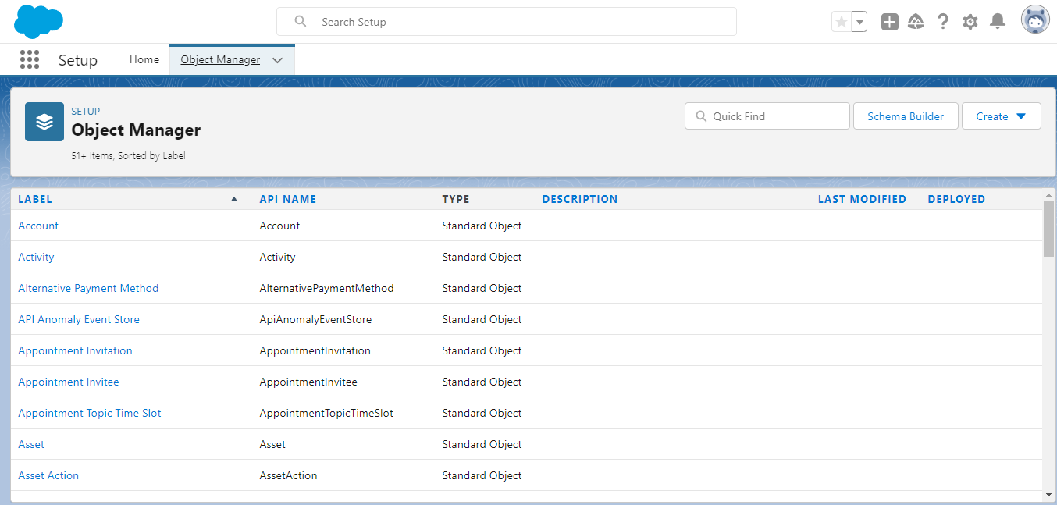

**Lightning App**:

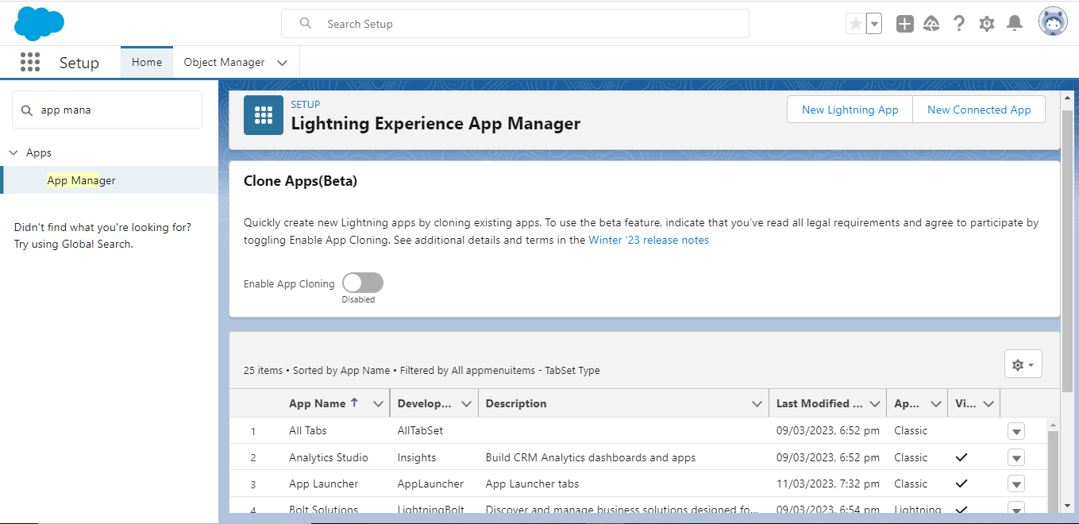

**Fields and Relationship**:

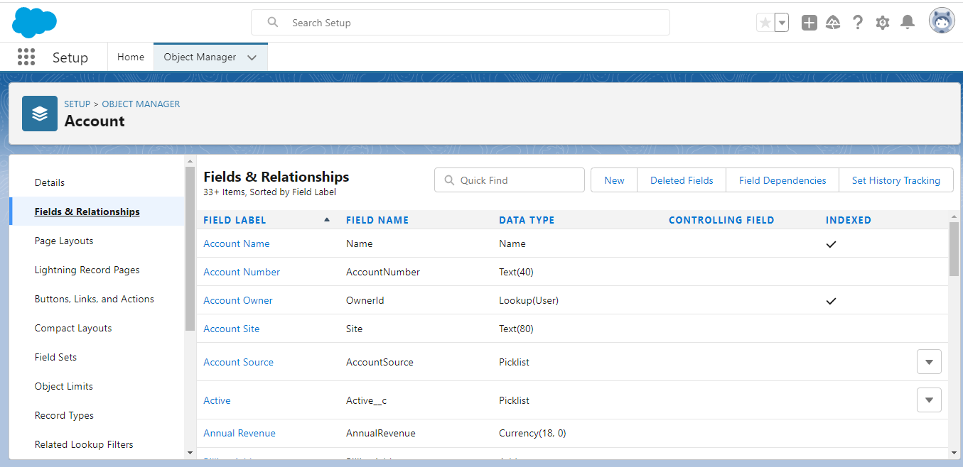

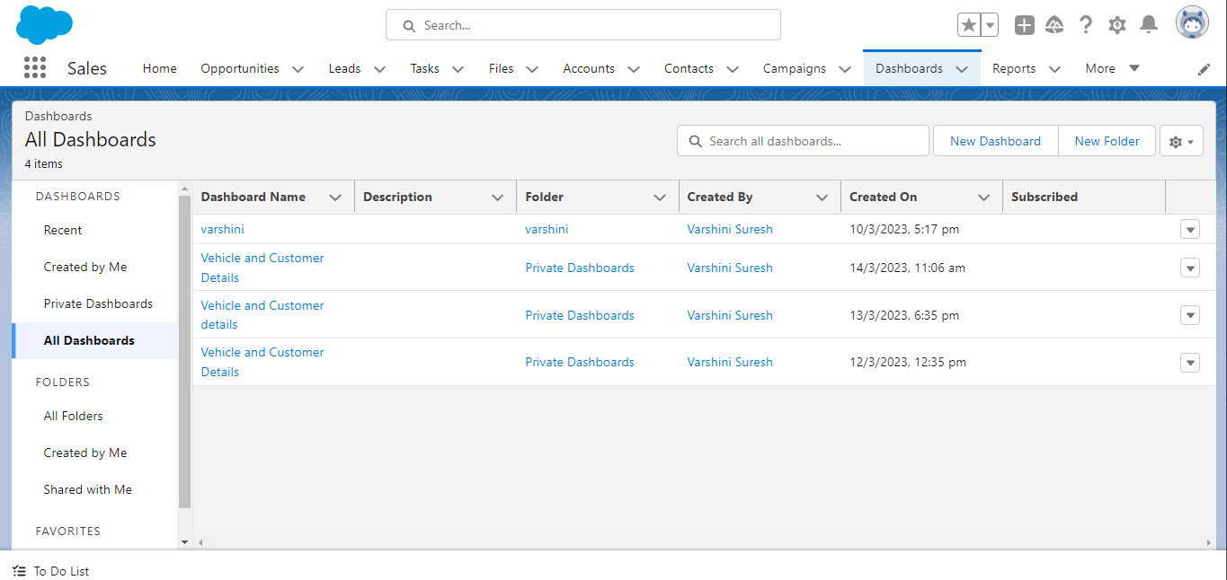

**Profile:**

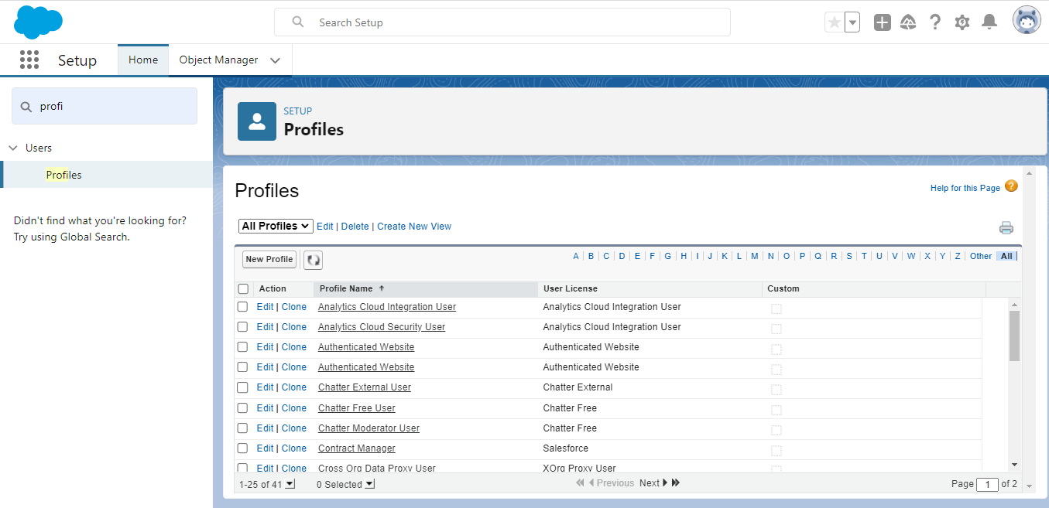

**Roles:**

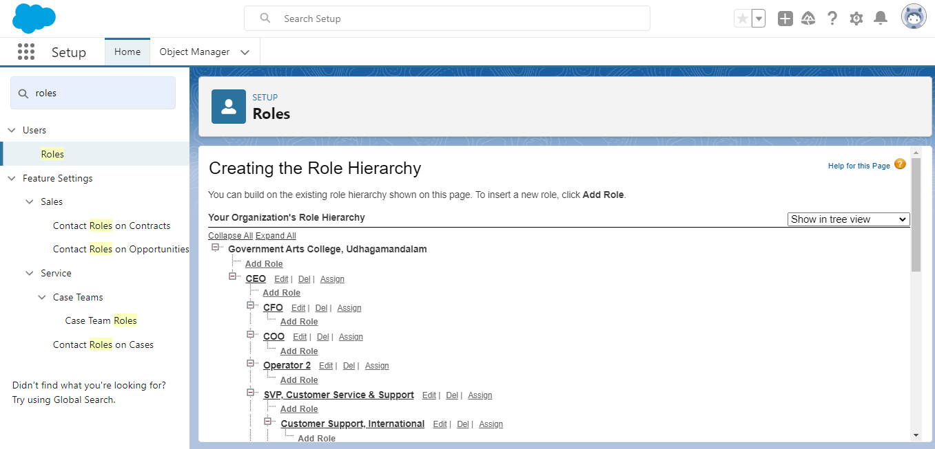

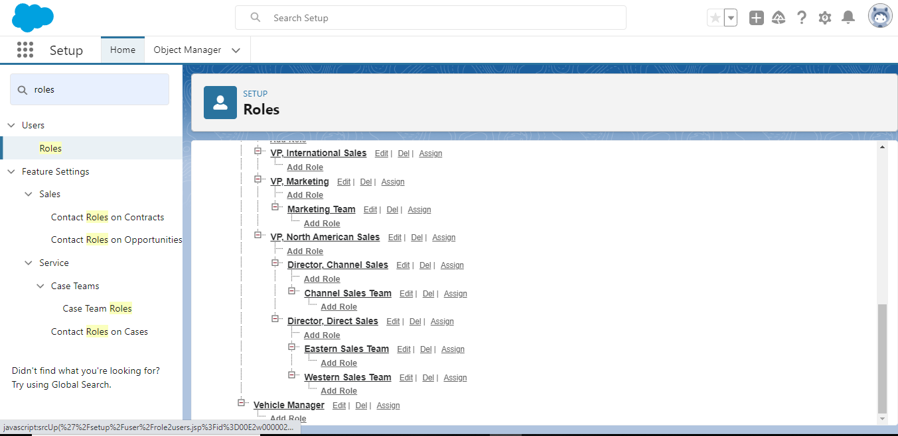

**Users:**

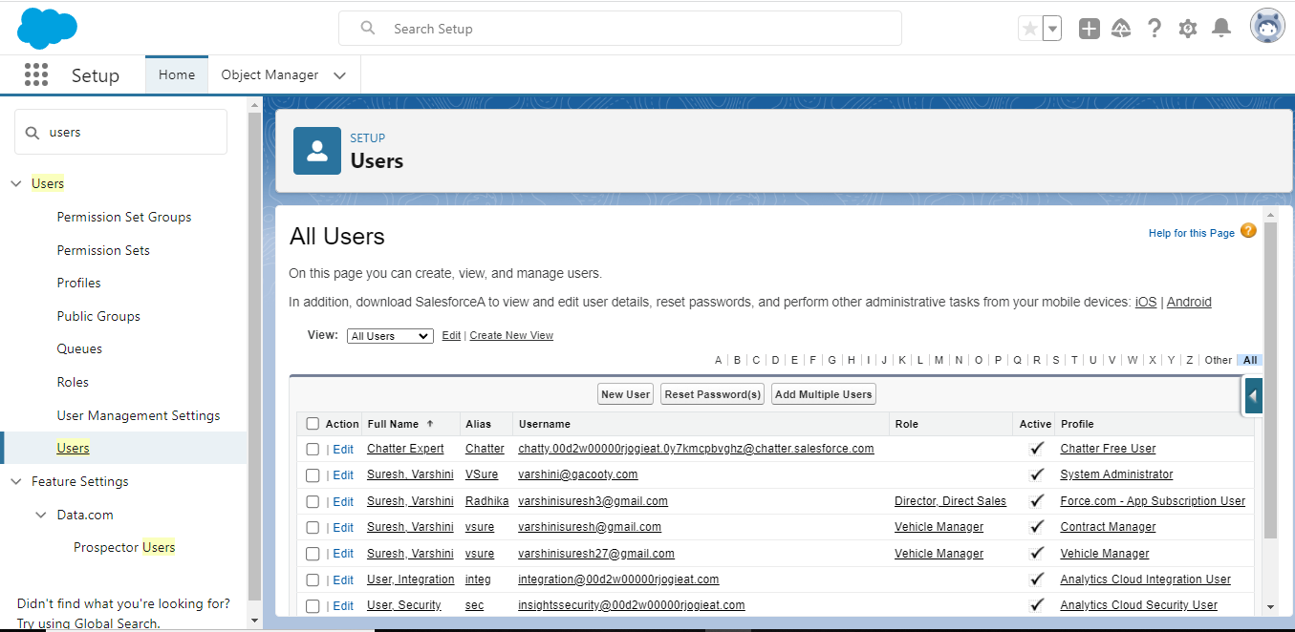

**Reports:**

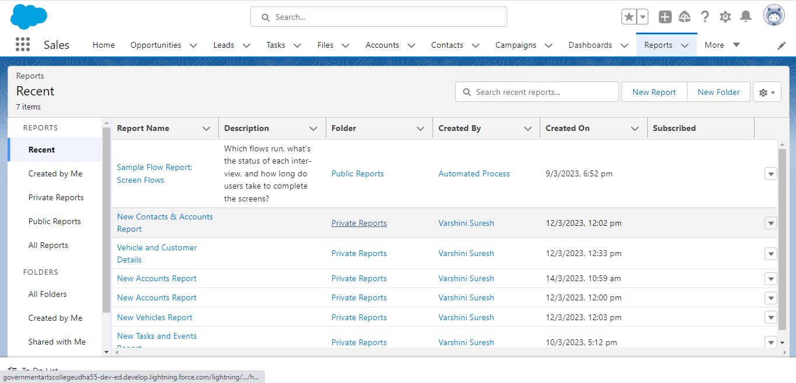

**Dashboard:**

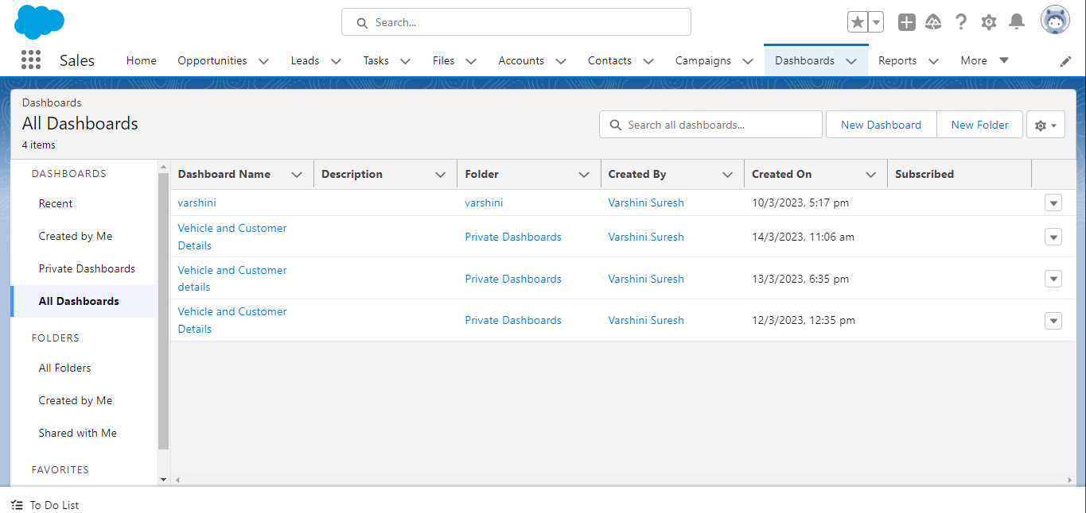

**Trailhead Profile Public URL**:

Team Leader : https://trailblazer.me/id/varsuresh45

Team Member 1: https://trailblazer.me/id/vists5

Team Member 2: https://trailblazer.me/id/velug6

Team Member 3: https://trailblazer.me/id/sudhj6

**Advantages and Disadvantages of Vehicle Management system:**

**Advantages :**

1. Centralized platform: The project Vehicle management using Salesforce provides a centralized platform to manage vehicles, drivers, and associated data, enabling easy access to information from a single location.

2. Customizable: Salesforce is highly customizable, allowing the development of a tailored solution for vehicle management that meets the specific requirements of the organization.

3. Scrable: As the organization grows, the project can easily scale up to manage a larger number of vehicles and drivers.

4. Integration: Salesforce can integrate with other systems such as accounting, inventory management, and logistics to provide a comprehensive solution.

5. Mobility: Salesforce is a cloud-based solution, allowing the organization to access vehicle and driver data from anywhere at any time.

**Disadvantages :**

1. Cost: Mobilityplementing the project Vehicle management using Salesforce may require a significant investment in software licenses, hardware, and development.

2. Complexity: Salesforce can be complex to set up and customize, requiring specialized knowledge and expertise.

3. Training: Users may require training to use the system effectively, adding additional costs and time to the project.

4. Data Security: The organization must ensure that sensitive data such as vehicle and driver information is adequately protected from unauthorized access.

5. Dependence on Salesforce: The organization may become dependent on Salesforce, which could create vendor lock-in and make it challenging to switch to a different system in the future

**Applications:**

1. Fleet management: Salesforce can be used to manage a fleet of vehicles, including tracking the location and status of each vehicle, scheduling maintenance, and managing fuel consumption.

2. Driver management: Salesforce can be used to manage the drivers of a fleet, including assigning tasks, tracking performance, and managing driver schedules.

3. Inventory management: Salesforce can be used to manage the inventory of a fleet, including tracking the availability of vehicles and parts, managing procurement, and monitoring usage.

4. Management: Salesforce can be used to manage the service and maintenance of vehicles in a fleet, including scheduling maintenance, tracking service history, and managing repair orders.

5. Reporting and analytics: Salesforce can be used to generate reports and analytics on various aspects of fleet management, including utilization rates, fuel consumption, maintenance costs, and driver performance.

Overall, project vehicle management using Salesforce can help organizations optimize their fleet operations, reduce costs, and improve productivity.

**Conclusion :**

Based on the information provided, it is difficult to draw a definitive conclusion about the project vehicle management using Salesforce. However, I can provide some general thoughts and considerations:

1. The use of Salesforce as a platform for vehicle management has several advantages, including the ability to track vehicles, maintenance schedules, and expenses, as well as generate reports and analytics.

2. The success of the project will depend on the effective implementation of Salesforce and the customization of the platform to meet the specific needs of the organization.

3. It is important to ensure that all stakeholders, including management, staff, and IT personnel, are involved in the project and that there is buy-in from all parties.

4. Support for staff will also be critical to ensure that the system is used effectively and efficiently.

5. Finally, ongoing evaluation and adjustment of the system will be necessary to ensure that it continues to meet the changing needs of the organization.

Overall, the use of Salesforce for vehicle management can be a valuable tool for organizations looking to streamline their processes and improve their ability to track and manage their vehicles. However, the success of the project will depend on careful planning, effective implementation, and ongoing evaluation and adjustment.

**Future Scope :**

The future scope for vehicle management projects is vast and exciting, with the growing trend of automation and technology integration in the automotive industry. Here are a few potential areas of development and growth:

1. Connected Vehicles: The development of connected vehicles, with features such as GPS tracking, real-time diagnostics, and predictive maintenance, is set to revolutionize vehicle management. With the integration of IoT devices, vehicles will be able to communicate with each other, providing real-time data on traffic, weather, and road conditions. This technology will enable fleet managers to optimize their routes and reduce fuel consumption, leading to significant cost savings.

2. Autonomous Vehicles: Autonomous vehicles are the future of transportation, and vehicle management will be at the forefront of this technology. With self-driving cars, fleet managers will be able to track and manage their vehicles remotely, reducing the need for human intervention. The use of autonomous vehicles will also reduce accidents and improve safety, leading to significant savings in insurance costs.

3. Artificial Intelligence: The use of Artificial Intelligence (AI) in vehicle management will enable fleet managers to predict vehicle failures before they occur, reducing maintenance costs and increasing vehicle uptime. AI algorithms will also be able to analyze driver behavior and optimize routes to reduce fuel consumption and emissions.

4. Electric Vehicles: The shift towards electric vehicles will bring new challenges for vehicle management. With the need for charging infrastructure and battery management, fleet managers will need to adopt new processes and technologies to manage their electric vehicles effectively. This includes battery management systems, charging station optimization, and route planning.

Overall, the future of vehicle management looks promising, with the integration of technology, automation, and sustainability leading the way.